CPSC 250

Homework #1

Chapter 2 Recursion & Chapter 10 Algorithm Efficiency

Due Date: Sunday, Sep. 26, 2021 (No Late Submissions will be Accepted.)

Grades depend on neatness and clarity. Write your answers with enough detail about your approach and concepts used, so that the grader will be able to understand it easily.

Submissions should be one file containing all answers.

Chapter 2 Recursion

- (10 points each for each exercise question) Textbook p 89 - 92, Exercises #1, 2, 6, 10, 11, 12, 13, 14, 15, and 16.

Chapter 10 Algorithm Efficiency

- Textbook p 311, Question 1

- Textbook p 311, Question 2

- Textbook p 317, Question 3

- Textbook p 320, Question 4

- Textbook p 321 - 322, Exercises #4, 5, and 6
CPSC 250

Chapter 2 Recursion
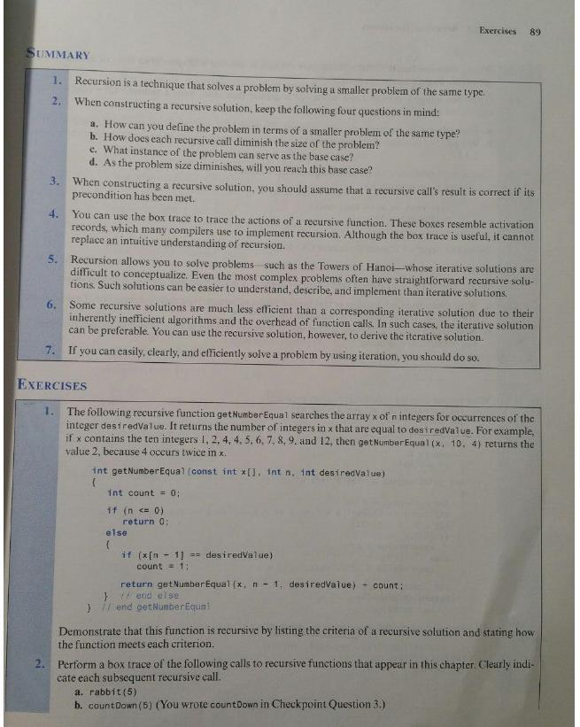
CPSC 250
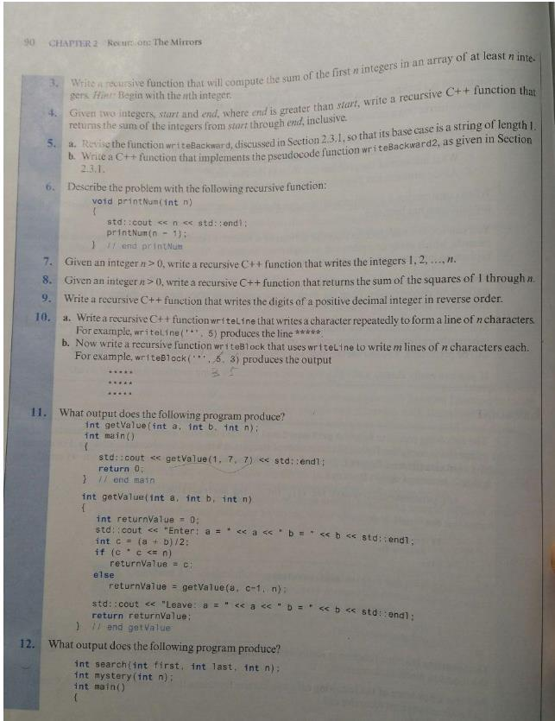
CPSC 250
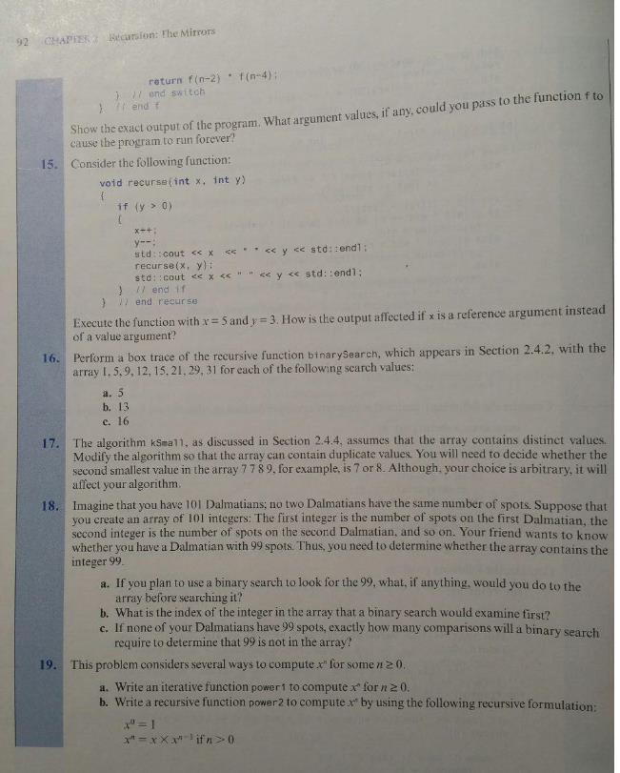
CPSC 250
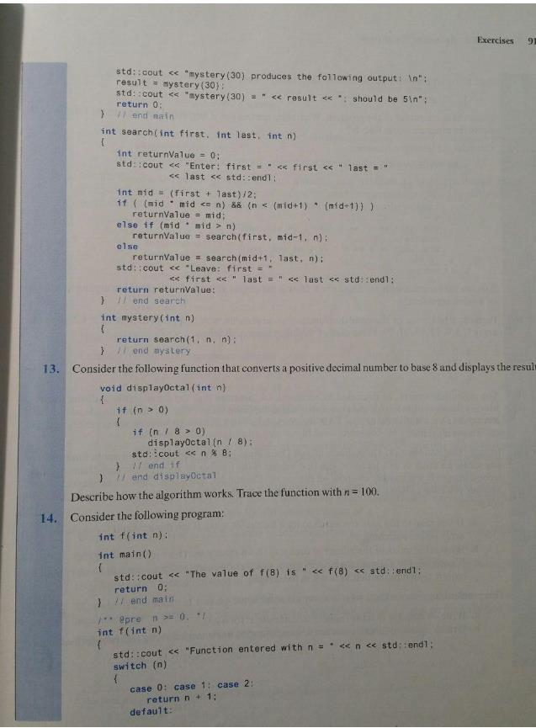
CPSC 250

Chapter 10 Algorithm Efficiency

Question 1 How many comparisons of array items do the following loops contain?

for (j = 1; j <= n - 1; j++)

{

i = j + 1;

do

{

if (theArray[i] < theArray[j])

swap(theArray[i], theArray[j]);

i++;

} while (i <= n);

}

Question 2 Repeat Question 1, replacing the statement ^{i = j + 1} with ^{i = j}.

Question 3 What order is an algorithm that has as a growth-rate function
a. 8 ^{x} n³ – 9 ^{x} n b. 7 ^{x} log2 n + 20 c. 7 ^{x} log2 n + n

Question 4 Consider a sequential search of n data items.

a. If the data items are sorted into ascending order, how can you determine that your desired item is not in the data collection without always making n comparisons?

b. What is the order of the sequential search algorithm when the desired item is not in the data collection? Do this for both sorted and unsorted data, and consider the best, average, and worst cases.

c. Show that if the sequential search algorithm finds the desired item in the data collection, the algorithm’s order does not depend upon whether or not the data items are sorted.

CPSC 250
